**Practical 4**

**Aim: Perform a practical to demonstrate a basic CLI of**

**router in Cisco Packet Tracer.**

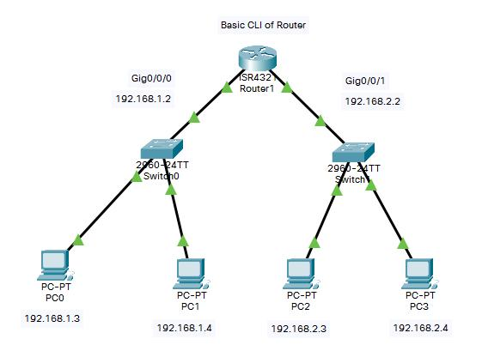

**CLI Commands**

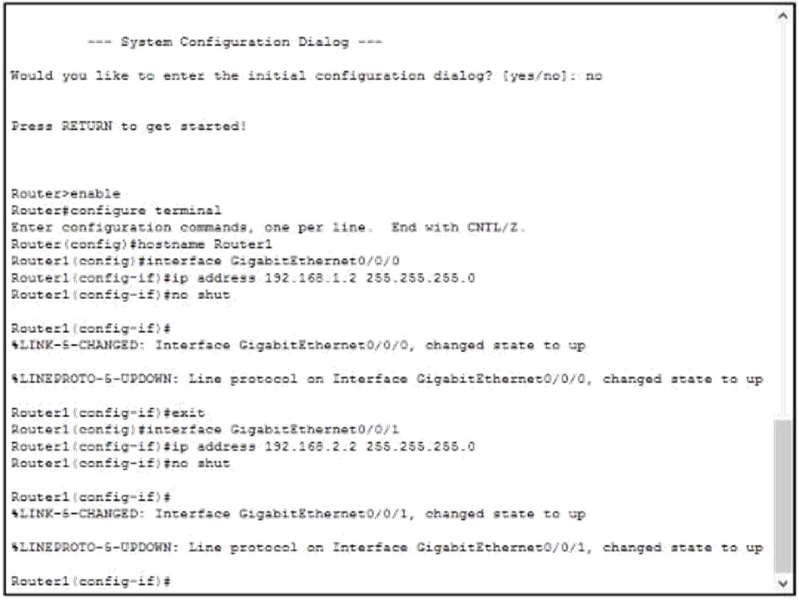

**Real time**

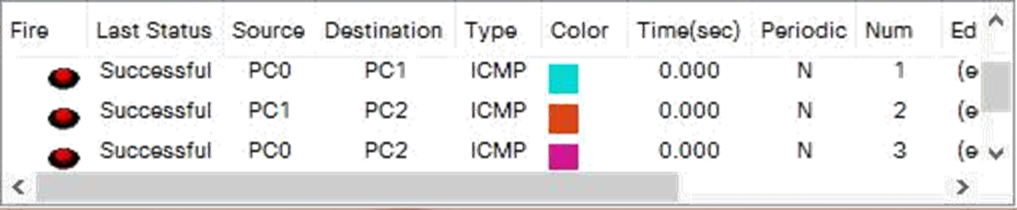

**Practical 5:**

**Aim: Perform a practical to configure static routing in Cisco Packet Tracer.**

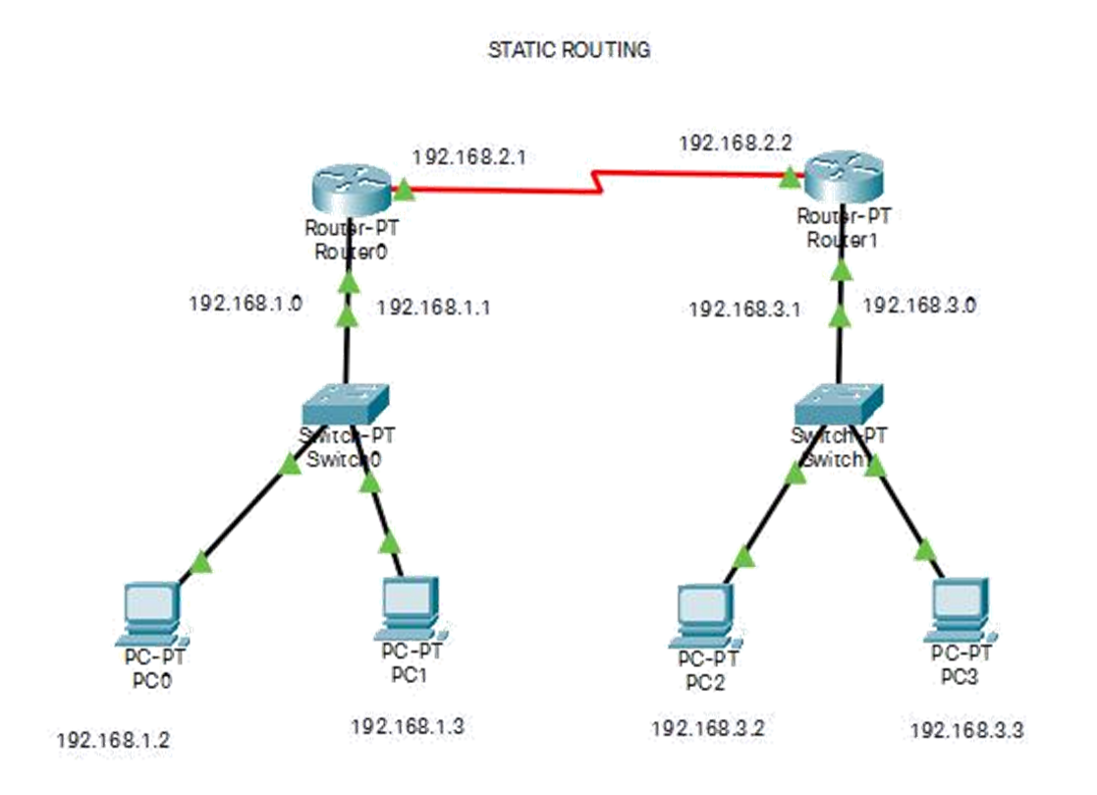

**CLI commands (Router0 and Router1):**

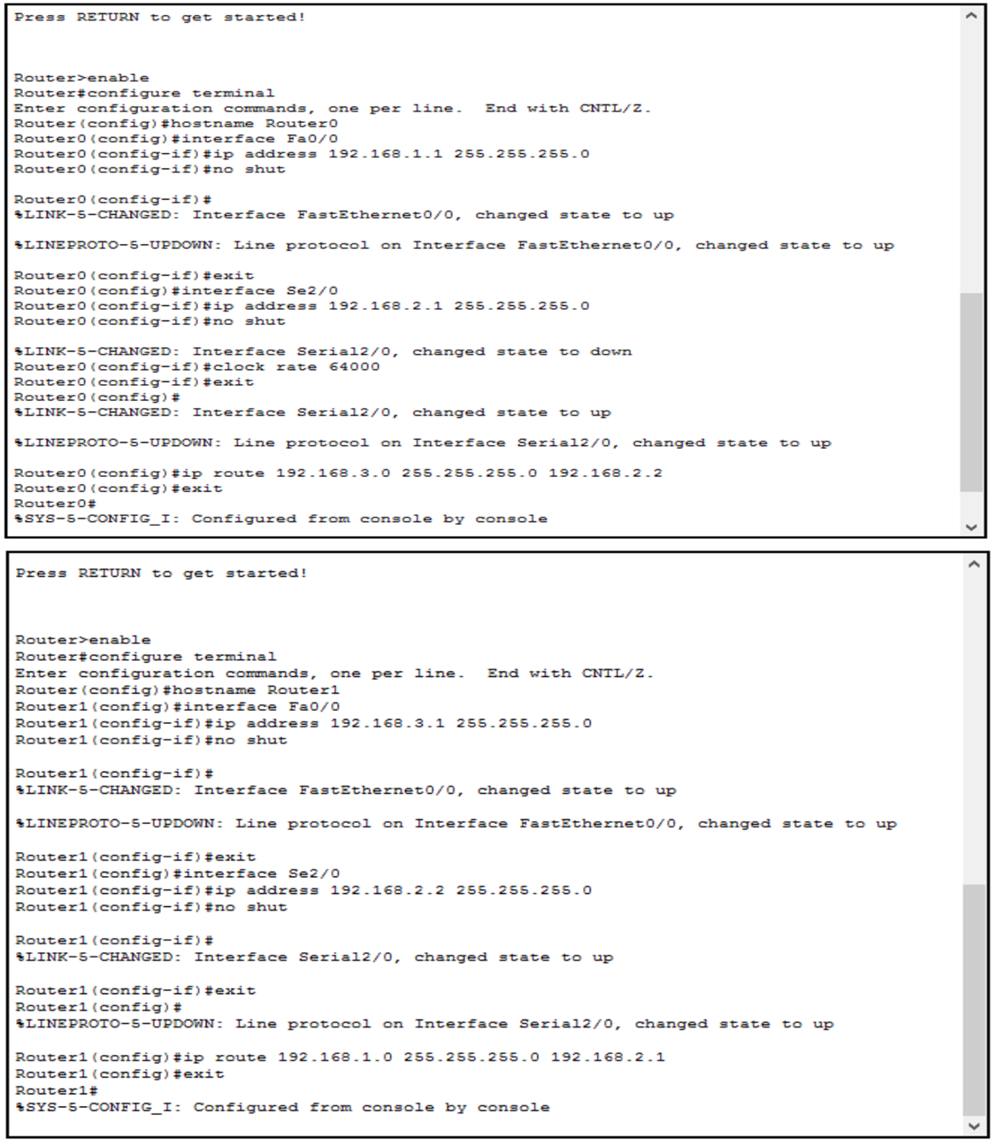

**Real time:**

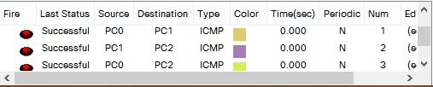

**Practical 6:**

**Aim: Perform a practical to configure dynamic routing in Cisco Packet Tracer.**

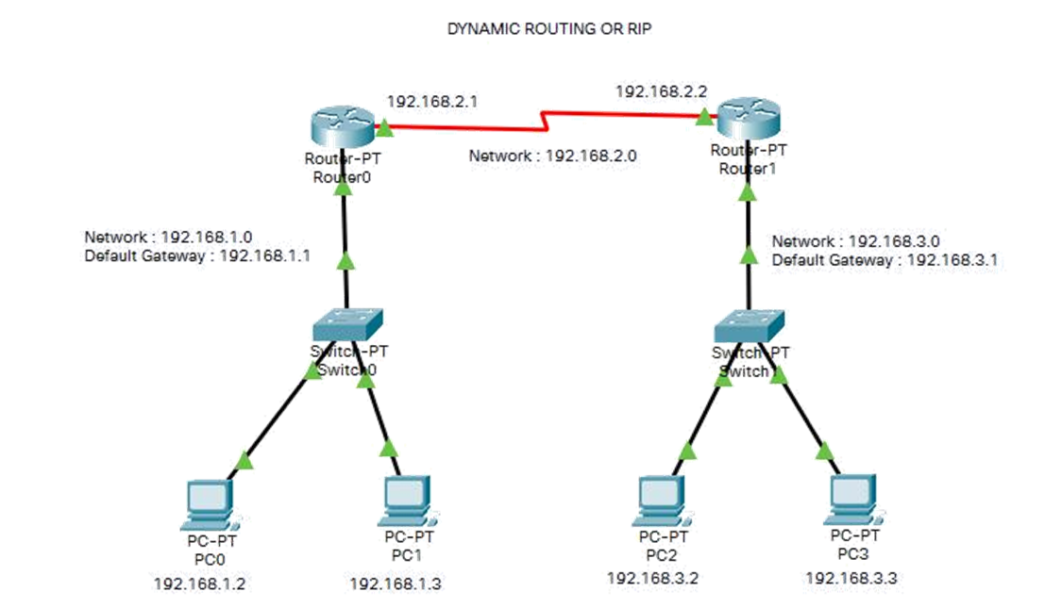

**CLI commands (Router0 and Router1):**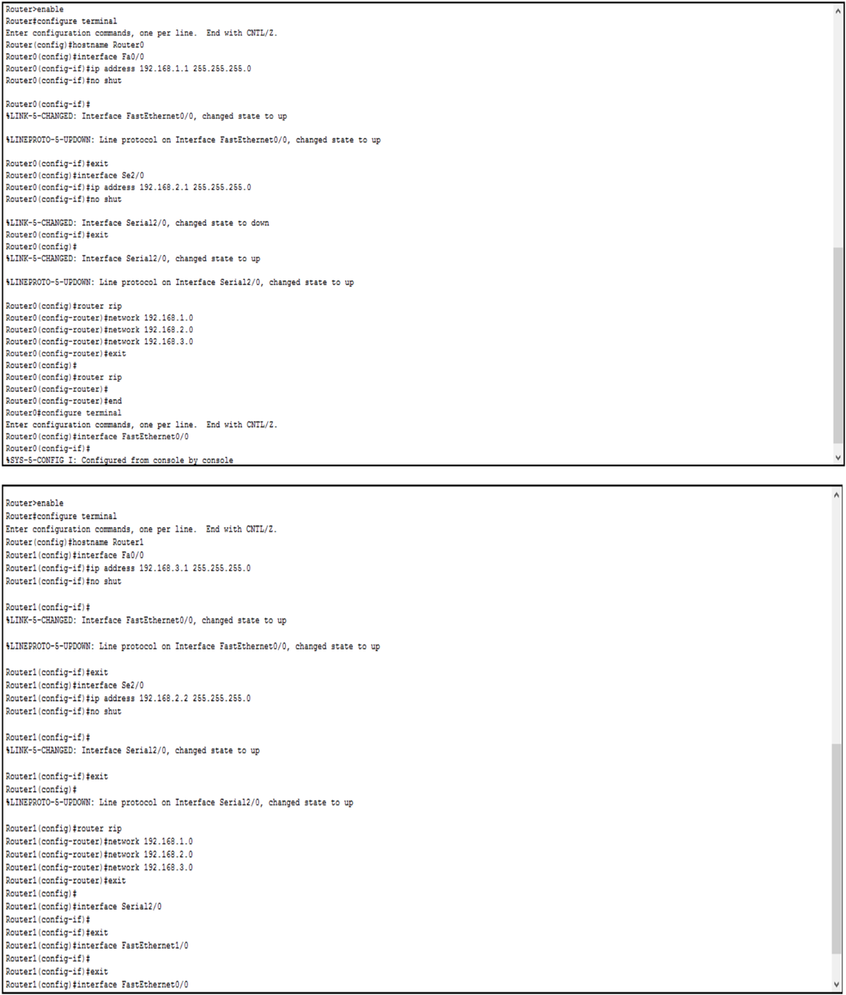

**Real time:**

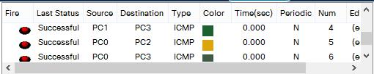

**Practical 7:**

**Aim: Perform a practical to configure DHCP in Cisco Packet Tracer.**

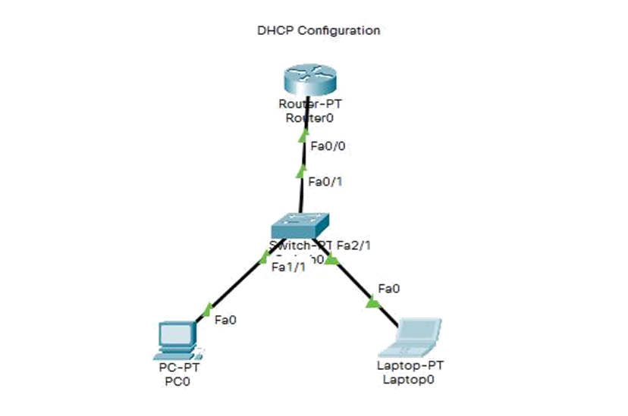

**CLI Commands:**

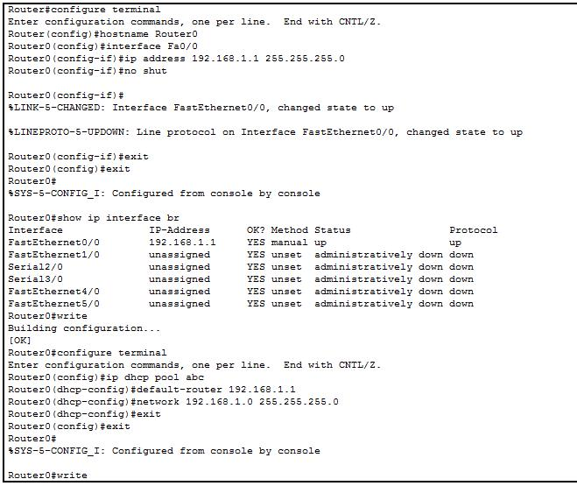

**Output:**

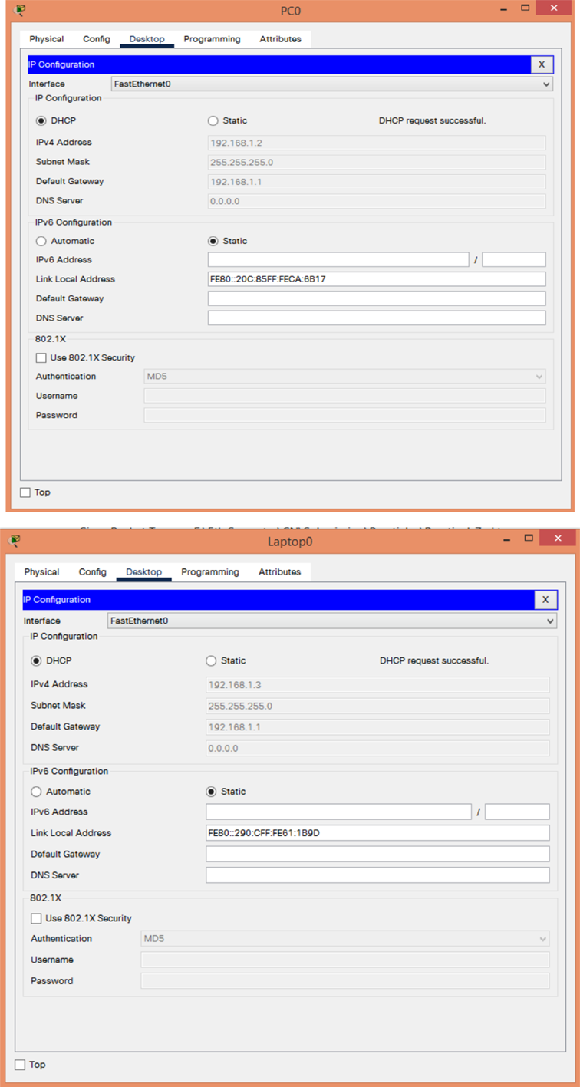

**Practical 8:**

**Aim: Perform a practical to configure DNS in Cisco Packet Tracer.**

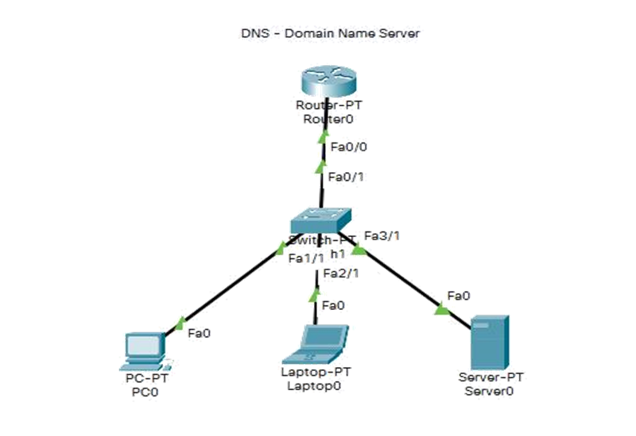

**CLI Commands:**

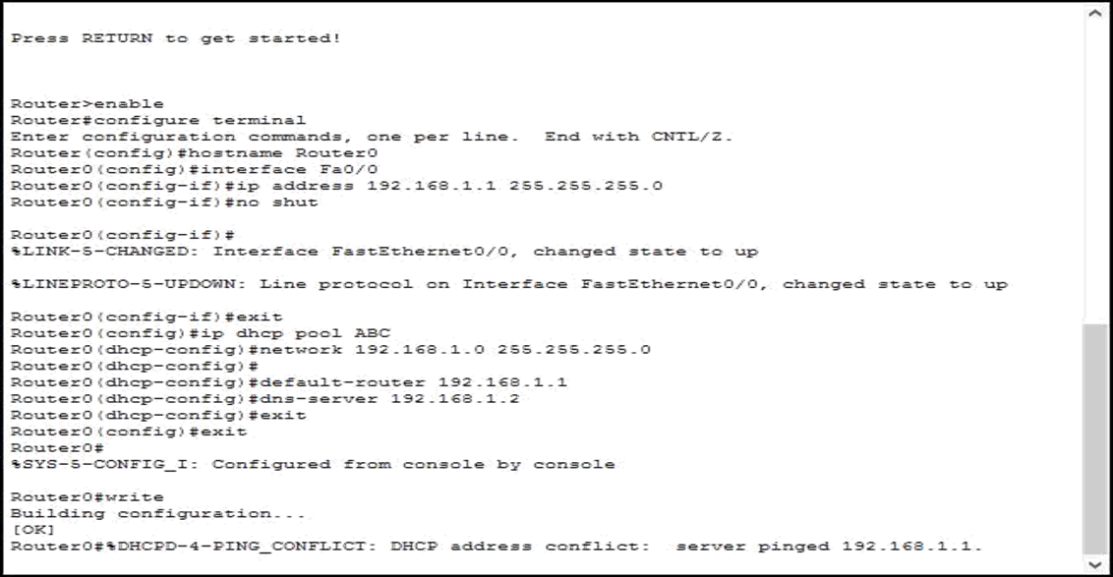

**Output:**

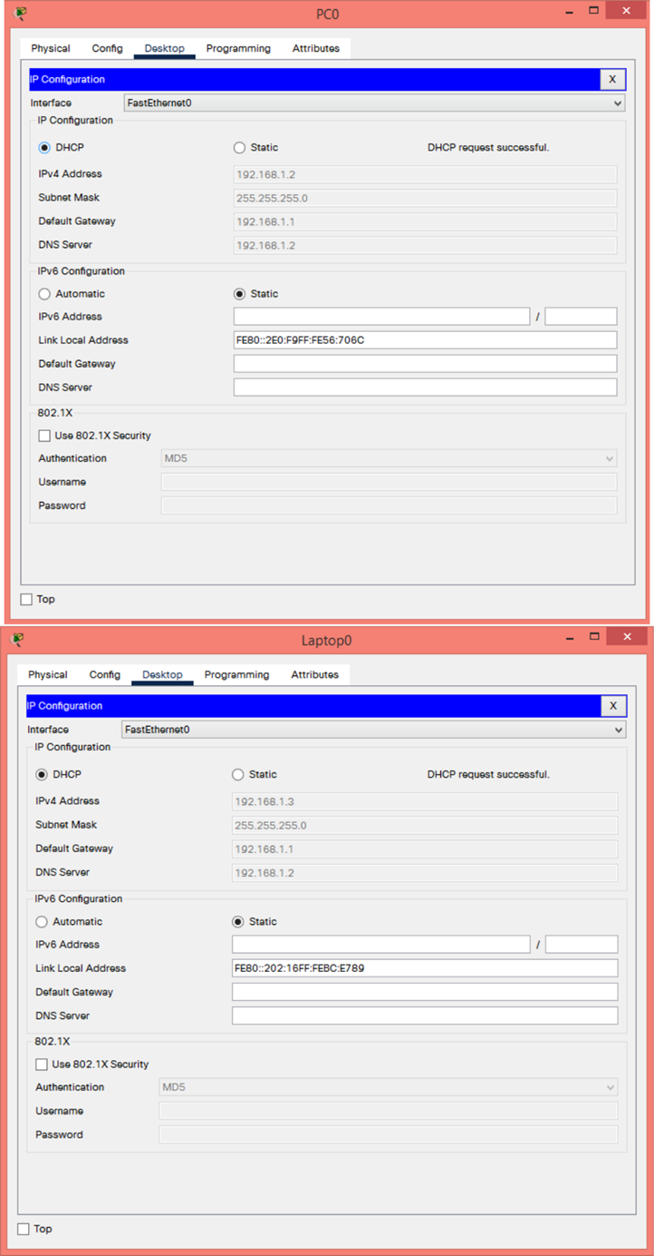

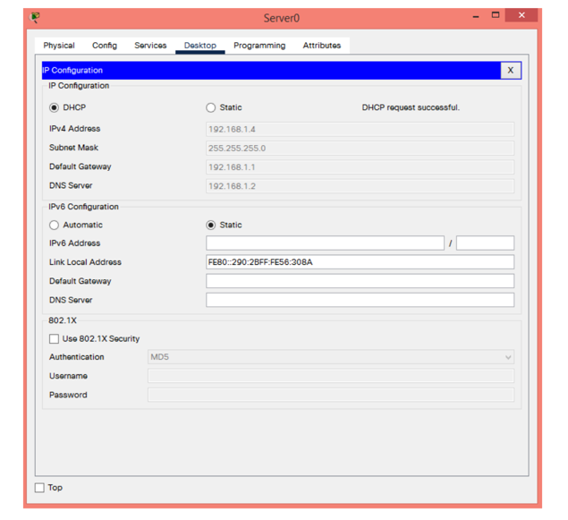

**DNS Table**

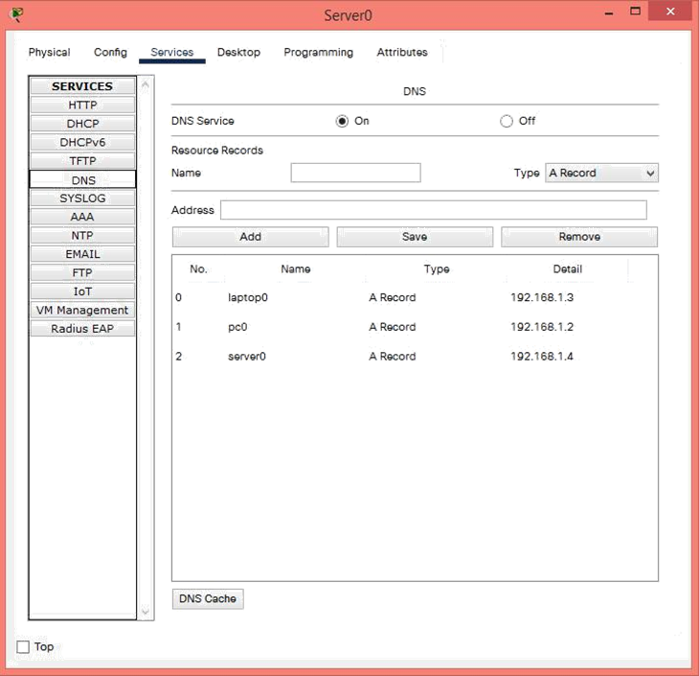

**Practical 9:**

**Aim: Perform a practical to configure TELNET in Cisco**

**Packet Tracer.**

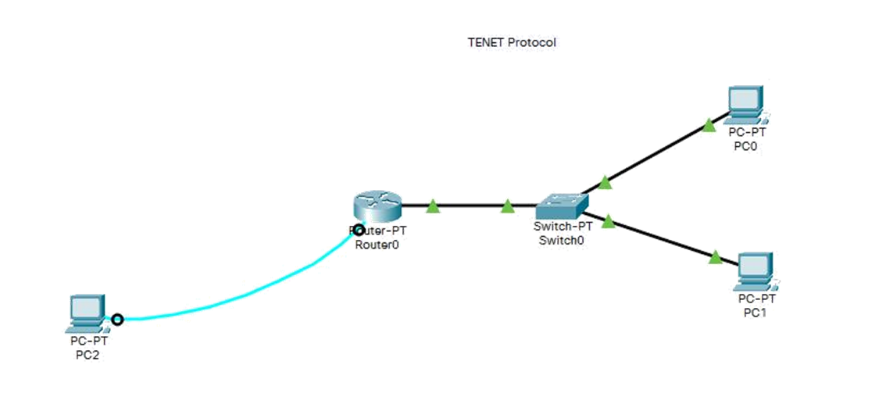

**CLI Commands:**

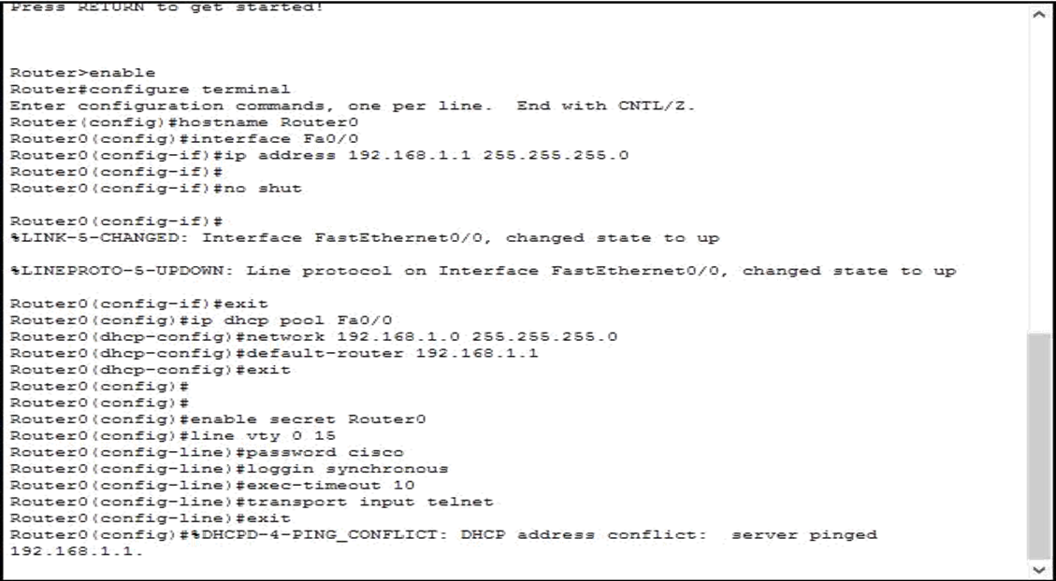

**Output:**

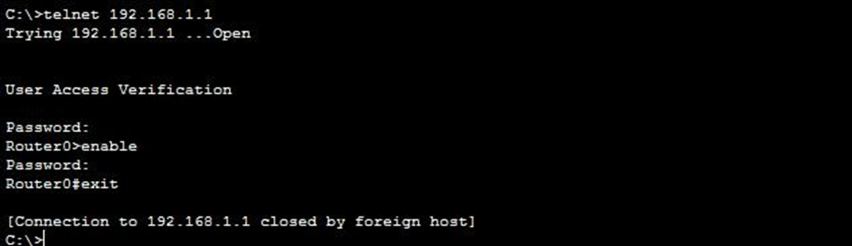

**Practical 10:**

**Aim: Perform a practical to configure SSH in Cisco Packet Tracer.**

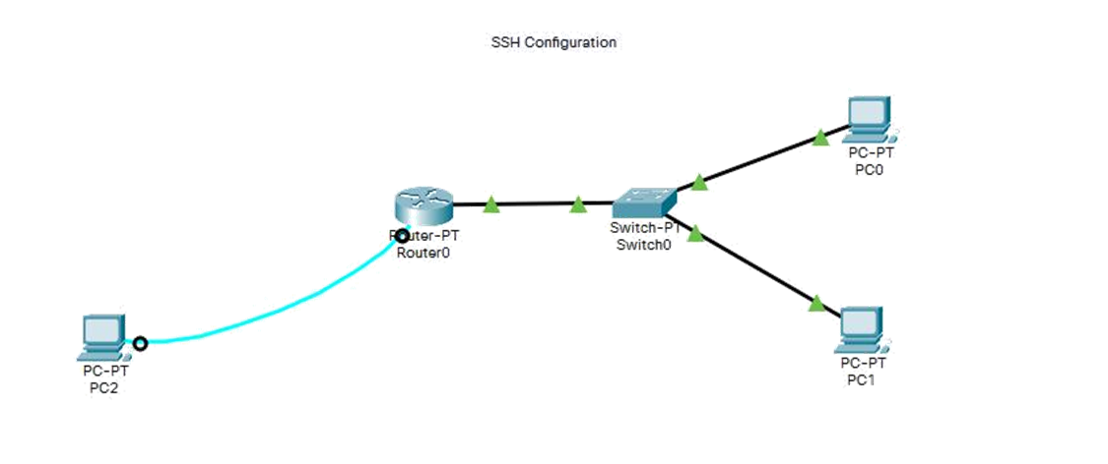

**CLI Commands:**

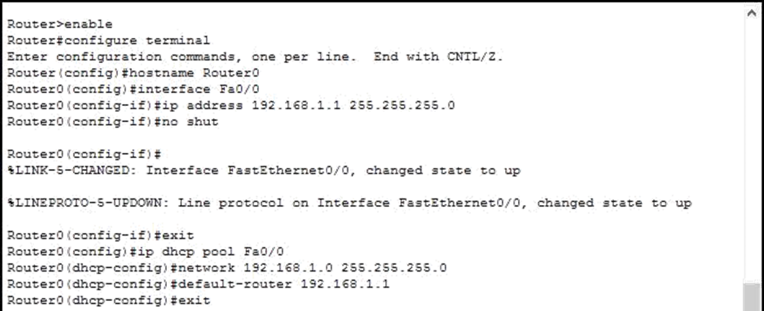

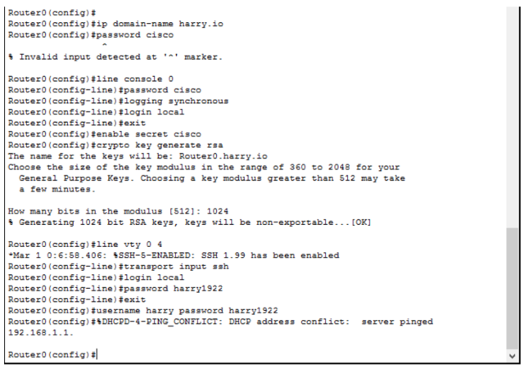

**Output:**

